

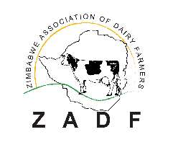****

**TENDER NOTICE**

Ref No:**International Tender:** WE EFFECT_FED/2019/403/017

We Effect, an International Swedish NGO, in partnership with Zimbabwe Association of Dairy Farmers, Zimbabwe Farmers Union and Zimbabwe Dairy Industry Trust, implementing a European Union financed Action entitled Zimbabwe Agricultural Growth Programme; Transforming the Zimbabwe Dairy Value Chain (DVC) for the Future (2019 – 2022) invites bids from reputable companies for the supply of the following vehicles to be used in the implementation of the Action.

We Effect Zimbabwe is inviting submissions of tenders for a contract to provide the following vehicles:

|  |  |  |  |
| --- | --- | --- | --- |
| Lot No. | Item | Quantity | Year |
| 1 | 4x4 Double Cab, 4WD, 2.4 - 2.8litres, off road | 5 | 2019 model |

Tender documents can be requested for free from [zimtender@weeffect.org](mailto:zimtender@weeffect.org) and submitted on[procurement.zimbabwe@weeffect.org](mailto:procurement.zimbabwe@weeffect.org)

Closing date for submission of bids is13thSeptember2019 at1700 GMT.