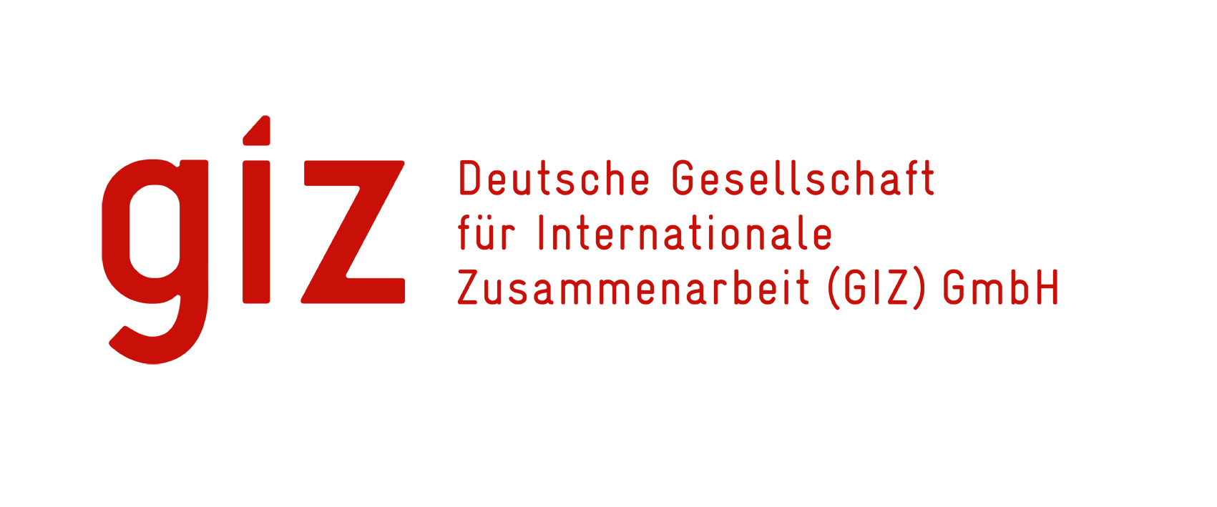

**TENDER NOTICE**

**for**

**Procurement of All in one PC/Desktop Computer, UPS for computer and Online UPS for laboratory equipment for ASSAM & BIHAR under the project “Indo-German Programme on Universal Health Coverage (IGUHC)”**

**RFP Nr : 91157376**

For over 60 years, the Deutsche Gesellschaft für Internationale Zusammenarbeit (GIZ) GmbH has been working jointly with partners in India for sustainable economic, ecological, and social development.

The focal areas of Indo-German cooperation/projects currently are:

* Energy
* Environment, Climate Change and Biodiversity
* Sustainable Urban and Industrial Development
* Sustainable Economic Development

**Indo-German Programme on Universal Health Coverage (IGUHC)** works with the Ministry Health & Family Welfare (MoHFW), the National Health Authority (NHA) and with selected State Governments to provide policy advice and implementation support in the areas of Universal Health Coverage (UHC) and convergence of social security programmes. IGUHC Programme is also implementing a project on of Corona Measures in India, to enable the State Governments to provide the treatment to COVID patient in identified hospitals need sourcing of All in one PC/Desktop Computer and UPS on immediate basis.

GIZ is looking for supplier who can provide the Computer & UPS as per the tender document.

The GIZ Country office in New Delhi which is responsible for Financial and Administrative matters invites bids for **Procurement of All in one PC/Desktop computer, UPS for computer and Online UPS for laboratory equipment for ASSAM & BIHAR under the project “Indo-German Programme on Universal Health Coverage (IGUHC), India**. The following documents are attached with the tender applications: -

The bidders are requested to go through the tender documents in detail and submit the proposal/bid as prescribed in tender documents.

**The bidding firm will have to submit the proposal in hard copy and in a sealed envelope to Head of Procurement, GIZ Country Office, New Delhi – Please refer to the bidding conditions mentioned in tender document and follow the instructions carefully.**

The detailed documentation with regards to this call for proposals includes:

* Tender Document
* Financial Formats – Annexure A

**Timeline;**

* **Deadline to receive queries                : 17th November’2021**
* **Clarifications to the queries               : 19th November’2021**

**The deadline for submission of proposal is: 26th November’2021 by 17:30hrs**

*GIZ reserves the right to cancel/modify this tender and /or reject a bid document including subsequently a technical and financial proposal, without assigning any reasons.*